EX.NO.2.

STAR TOPOLOGY USING PACKET TRACER

AIM:

To establish star topology using cisco packet tracer.

REQUIREMENTS:

1.End devices(pc) – they are the devices through which we can pass message from one devices to another and they are interconnected.

2.Hub – interface between two devices.

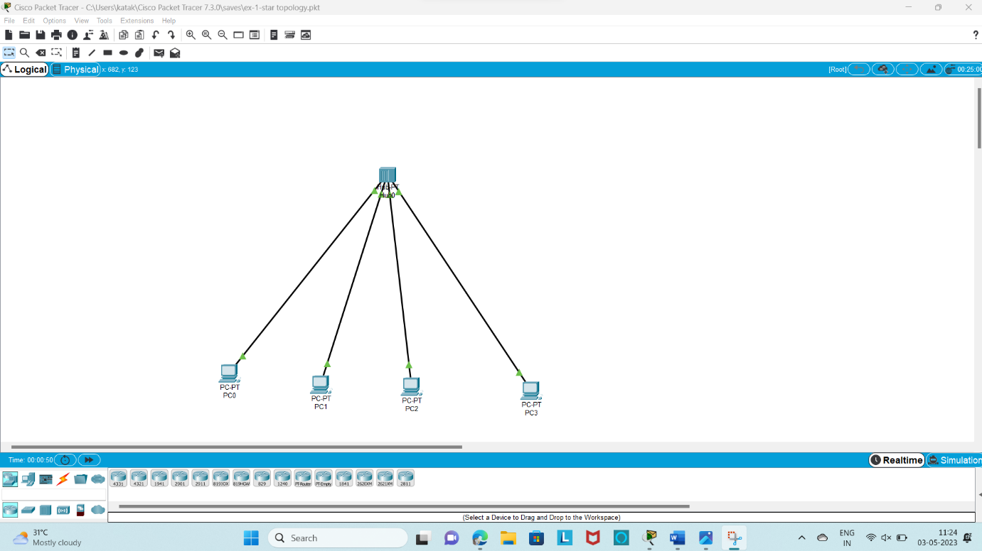

three system are connected to a hub using straight cable and assign ipaddress for each host separately(111.1.1.1,111.1.1.2,111.1.1.3,111.1,1,4)pc0,pc1,pc2,pc3.

PROCEDURE:

1.the main objective is to set up a star topology.

2.the concept involved in this network are IPADDRESSING.

3.The equipements required are 111.1.1.1-pc0,111.1.1.2-pc2,111.1.1.3-pc1,111.1.1.4-pc3.

4.when the physical LAN is set up the host need to be configured using the“ipconfigaration”commands.

5.To verify communication among the machine the ping command is used.

6.Manipulate the routing tables at the host to understand how machines know where to send packets.

7.The ipconfig command places a default route into the routing tables, hence this route

must be deleted to ‘blindfold’ the machine.

8. The ping command is used again to show that communication is no longer available.

9. To re-establish communication the routes are put back into the routing table one host at a time.

10. Communication is once again verified using the ping command.

IMPLEMENTATION;

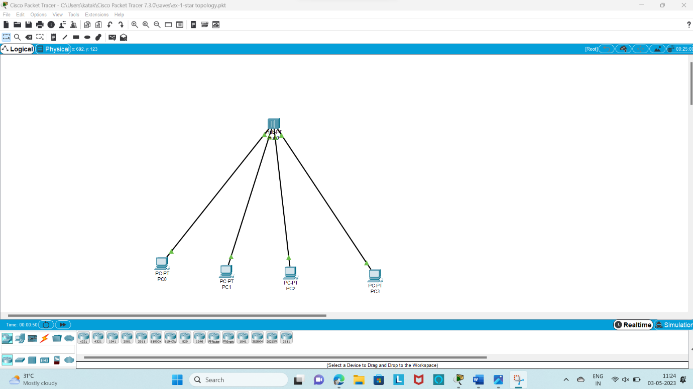

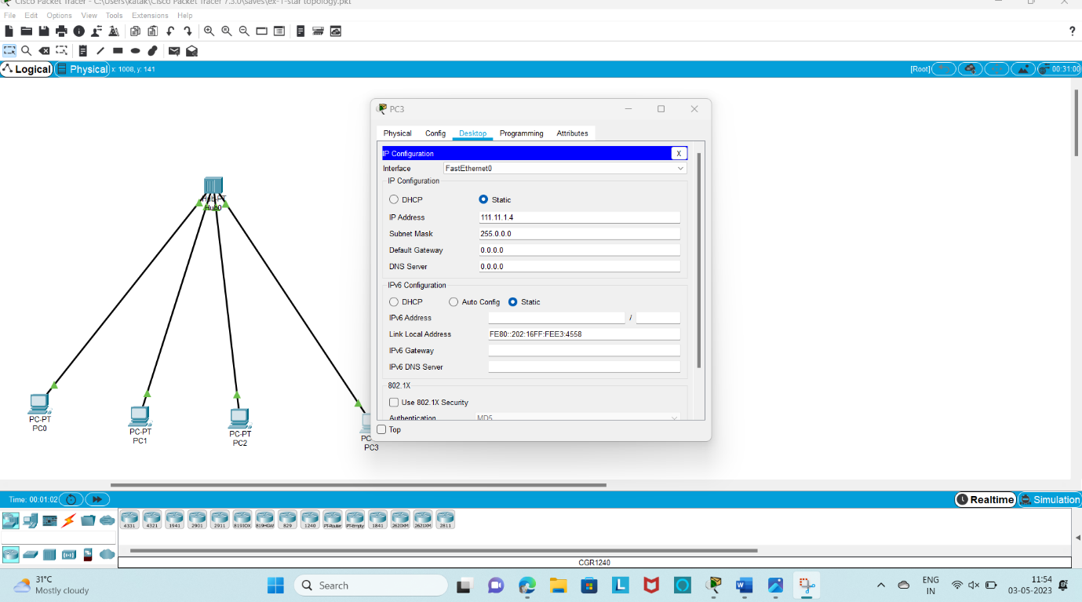

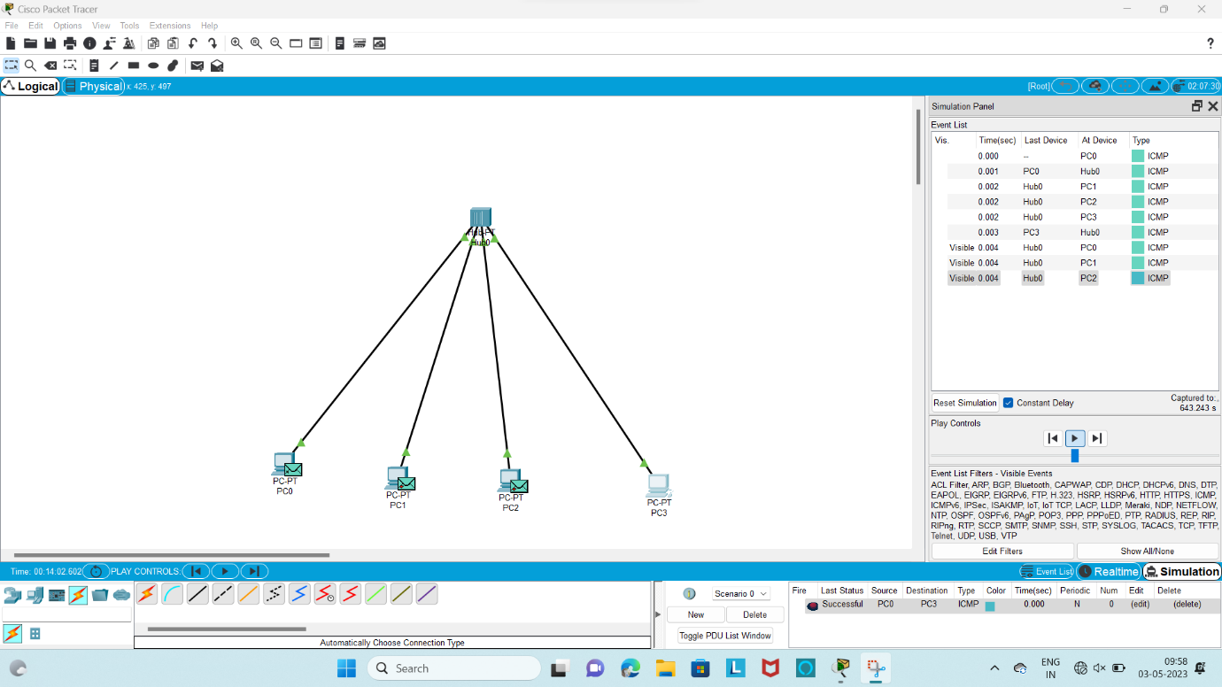

RESULT;

Thus, the star topology network was established and the communication among the systems is verified successfully